**Caregiver Benefits Application (10-10CG)**

**Table of Contents**

Caregiver Benefits Application Overview 2

User Access 3

Who can access this application? 3

Navigation 4

Maintenance Windows 5

How Do I Apply? 6

Program of Comprehensive Assistance for Family Caregivers (PCAFC) Application 9

Veteran Information 9

Veteran Health Care Information 13

Primary Family Caregiver Selection 15

Primary Family Caregiver Information 17

Primary Family Caregiver Health Care Information 21

Secondary Family Caregiver Selection 22

Secondary Family Caregiver Information 25

Secondary Family Caregiver (2) Information 28

Representative documentation 32

Review and Submission 37

Reviewing the Application 37

Signature Section 40

Submitting the Application 44

Troubleshooting a Submission Error 45

Table of Figures 47

# Caregiver Benefits Application Overview

VA’s Program of Comprehensive Assistance for Family Caregivers (PCAFC) provides support and services to caregivers of eligible Veterans who have incurred a serious injury in the line of duty either on or after September 11, 2001, or on or before May 7, 1975.

To apply for PCAFC, Veterans and Family Caregivers must complete VA Form 10-10CG. This product guide provides instruction on the application process for online submission. The online application can be used to apply with a Primary Family Caregiver, and/or up to two Secondary Family Caregivers. The online form can accommodate applications with:

* Veteran and Primary Family Caregiver
* Veteran, Primary Family Caregiver, and Secondary Family Caregiver
* Veteran, Primary Family Caregiver, Secondary Family Caregiver, and additional Secondary Family Caregiver
* Veteran and Secondary Family Caregiver
* Veteran, Secondary Family Caregiver, and additional Secondary Family Caregiver

The application is now supporting the ability for Veterans with a legal representative (such as legal guardian) to complete the online application. Representatives will be able to upload their documentation and sign their name on behalf of the Veteran.

VA’s Caregiver Support Program offers a wide variety of support services for caregivers of Veterans. Partnerships continue to be created or enhanced to broaden services and support for caregivers. Learn more by visiting the [Caregiver Support Program](https://www.caregiver.va.gov/) website or by calling the Caregiver Support Line at 855-260-3274 for more information.

**User Access**

### **Who can access this application?**

This application is completed by Veterans and Family Caregivers. Each application can include a Primary Family Caregiver and up to two Secondary Family Caregivers.

Veteran information is required for every application, and each Family Caregiver applicant will need to complete their own section of the form. The Veteran and all Family Caregivers are required to check confirmation boxes on the submission page.

Unlike other forms on VA.gov, applicants do not sign in to complete the online version of the 10-10CG. You can reference Figure 1 below screenshot for more information on eligibility:

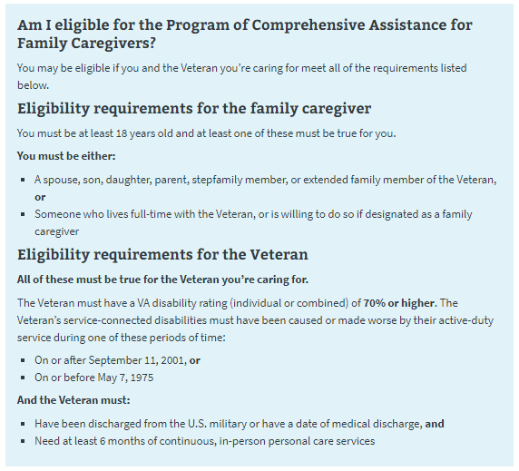  
*Figure 1. 10-10CG eligibility information.*

### **Navigation**

Begin the application at <https://www.va.gov/family-member-benefits/apply-for-caregiver-assistance-form-10-10cg/> (see Figure 2).  
  
*Figure 2. Beginning the application.*

Information about the program, as well as a link to the form, can be found on the Program of Comprehensive Assistance for Family Caregivers page (<https://www.va.gov/family-member-benefits/comprehensive-assistance-for-family-caregivers/>). See Figure 3.

*Figure 3. Information on the Program of Comprehensive Assistance for Family Caregivers.*

Maintenance Windows

The technical systems that support the online family caregiver application undergoes occasional maintenance. During this time, any online submissions will not go through. When such a maintenance window is coming up within 1 hour, users who navigate to the online form will see this message (Figure 4), which specifies when the maintenance will begin and end:

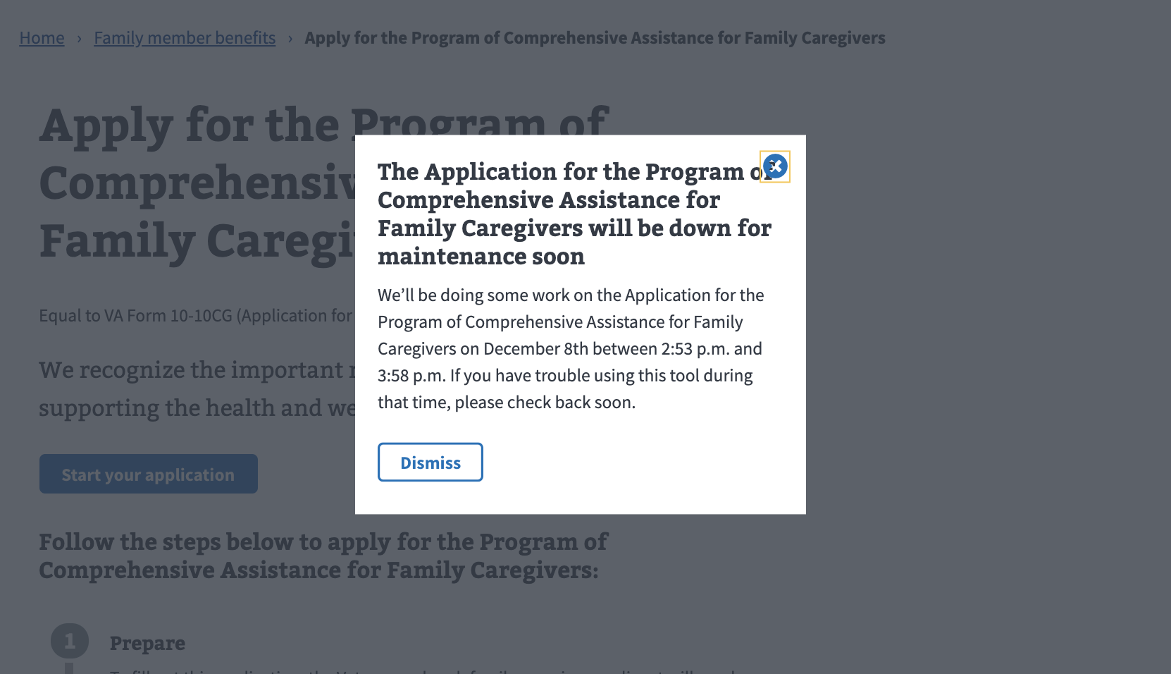  
*Figure 4. Notice of upcoming scheduled maintenance.*

If the user navigates to the form once a maintenance window is underway, they will see the following message (Figure 5), and will be unable to start the online application:

*Figure 5. Tool unavailable due to maintenance.*

# How Do I Apply?

The application page provides instructions on how to apply for the Program of Comprehensive Assistance for Family Caregivers and what information is needed to complete the form (Figure 6). This page also directs the user to the application once they are ready to apply.  
  
*Figure 6. Pre-application information for Program of Comprehensive Assistance for Family Caregivers.*

A drop-down link gives applicants additional information about Caregiver Support Coordinators (Figure 7).

*Figure 7. Caregiver Support Coordinator information.*

# Program of Comprehensive Assistance for Family Caregivers (PCAFC) Application

### **Veteran Information**

First, the Veteran will be asked to fill in general personal information (Figure 8).

*Figure 8. General Veteran identification information for 10-10CG application.*

The application will tell the Veteran what must be filled in. If they do not enter all the required information, they will not be allowed to move on to the next page.

The Veteran’s Social Security number or tax information number is needed to process the 10-10CG form online (Figure 9). If they don’t supply a number, they will receive an error message.

*Figure 9. Area where user enters Veteran’s Social Security or tax information.*

A Social Security number or tax identification number is not a requirement to apply or participate in the program. If the Veteran doesn’t want to supply their Social Security number or tax identification number, they can still apply to the program by downloading a copy of the form to fill out, sign, and send to VA via mail.

Next, the Veteran will be asked to fill in contact information (Figure 10).

*Figure 10. Veteran contact information.*

The primary phone number (Figure 11) is required so a Caregiver Support Coordinator can contact the Veteran to discuss the application. Email is not a required field.

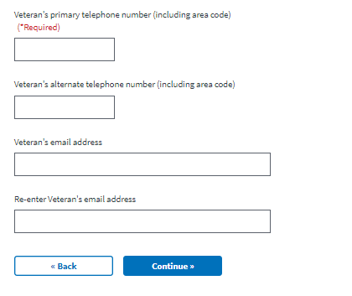

*Figure 11. Area for primary phone number.*

If they do not enter all the required information, they will not be allowed to move on to the next page.

### **Veteran Health Care Information**

Next, the Veteran will be asked to enter information about where they last received health care services (Figure 12). This information is requested but is not required to submit the form. If the Veteran enters a medical facility name or selects Hospital or Clinic, they will be required to answer the other question in this field.

*Figure 12. Section for recent medical care.*

Then, the Veteran will be asked where they plan to receive VA health care (Figure 13). This is so the application can be reviewed by a Caregiver Support Coordinator at that location. This information is required to complete the form.

*Figure 13. Where the Veteran plans to receive care.*

**Primary Family Caregiver Selection**

Next, the Veteran will be asked if they would like to apply for benefits for a Primary Family Caregiver (Figure 14). If Yes, the next step will be to add the Primary Family Caregiver Information. If No, the Veteran will skip to Secondary Family Caregiver Selection (Page 24 of this guide). The question must be answered to proceed.



*****Figure 14. Applying for benefits for a primary caregiver.*

The definition of a Primary Family Caregiver can be accessed through a drop-down link (Figure 15).

*Figure 15. Definition of Primary Family Caregiver.*

### **Primary Family Caregiver Information**

If the Veteran is applying with a Primary Family Caregiver, the person applying to be the Primary Family Caregiver will be asked to enter general personal information (Figure 16).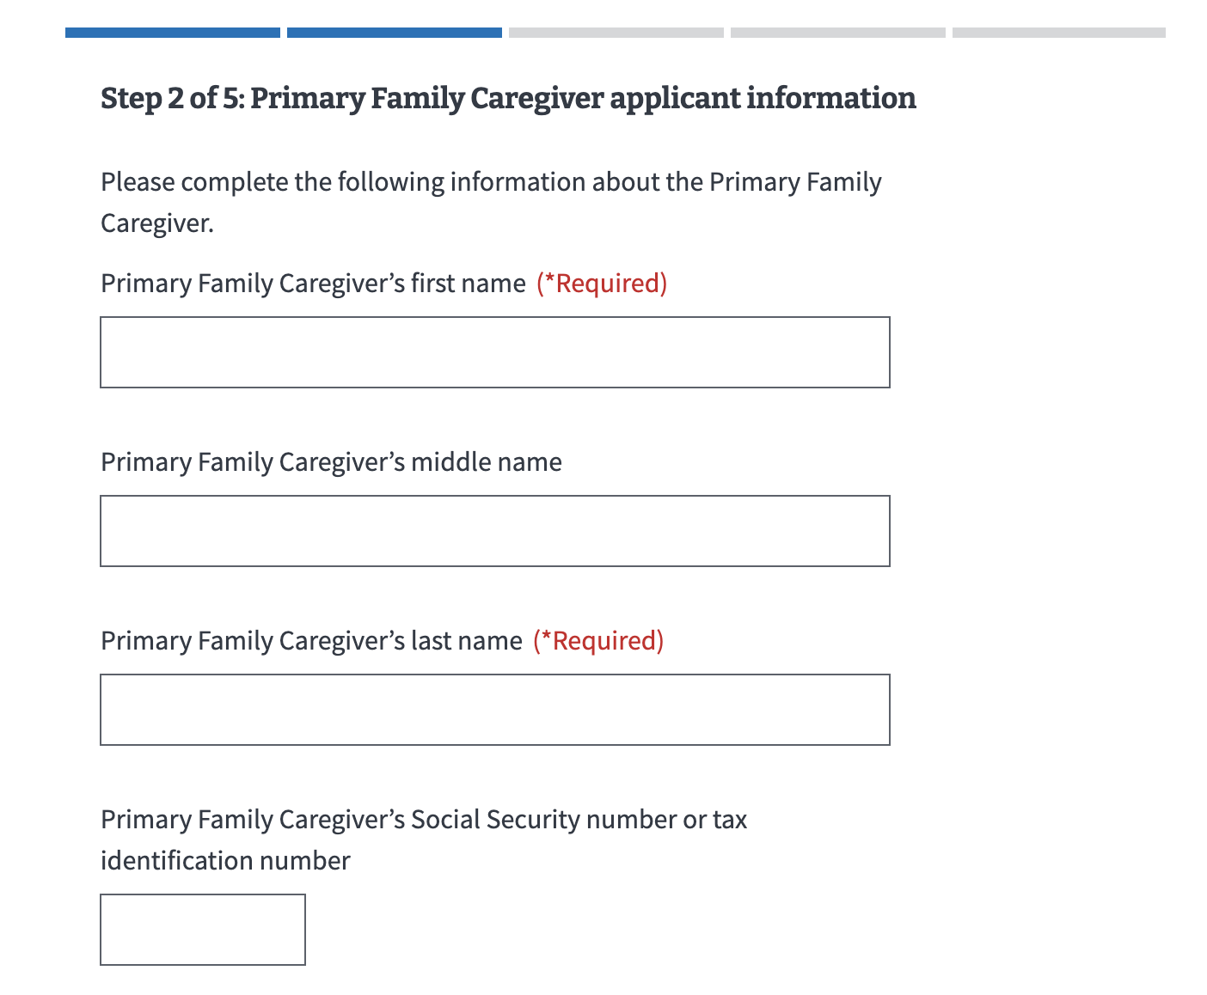  
*Figure 16. Primary Family Caregiver general information.*

The application will tell the Primary Family Caregiver what must be filled in. If they do not enter all the required information, they will not be allowed to move on to the next page.

The Primary Family Caregiver’s Social Security number or tax identification number is requested, but not required to apply for the program. The caregiver applicant will receive an error message if they put in a number that is not 9 digits, or if they repeat a number that has been entered elsewhere on the form (Figure 17).

*Figure 17. Social Security or tax ID number error.*

Next, the Primary Family Caregiver will be asked to fill in contact information (Figure 18).

*Figure 18. Caregiver contact information.*

The primary phone number is required so a Caregiver Support Coordinator can contact the Primary Family Caregiver to discuss the application (Figure 19). Email is not a required field.  
  
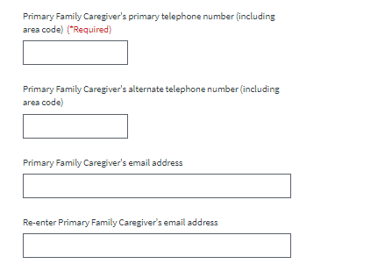

*Figure 19. Required caregiver phone number.*

A drop-down menu prompts the Primary Family Caregiver to indicate their relationship with the Veteran (Figure 20). The form will not allow the applicant to continue without providing a response.

### *Figure 20. Caregiver relationship to Veteran.*

### **Primary Family Caregiver Health Care Information**

Next, the Primary Family Caregiver will be asked about their current health care coverage (Figure 21). They will be required to answer “yes” or “no.”

*Figure 21. Caregiver’s health coverage.*

### **Secondary Family Caregiver Selection**

Next, the Veteran will be asked if they would like to apply for benefits for a Secondary Family Caregiver (Figure 22). If Yes, the next step will be to add the Secondary Family Caregiver information. If there is a Primary Family Caregiver on the application, Secondary Family Caregivers are optional. Each Veteran can have up to 1 Primary Family Caregiver and 2 Secondary Family Caregivers. If there is no Primary Family Caregiver on the application, the Veteran will need to add Secondary Family Caregiver(s).

*****Figure 22. Secondary Family Caregiver.*

The definition of a Secondary Family Caregiver can be accessed by clicking the drop-down link (Figure 23).

*Figure 23. Secondar Family Caregiver definition.*

If the application has a Primary Family Caregiver and they do not add a Secondary Family Caregiver, they will advance to the review screen.

If the application does not have a Primary Family Caregiver and they do not add a Secondary Family Caregiver, they see this error message (Figure 24):

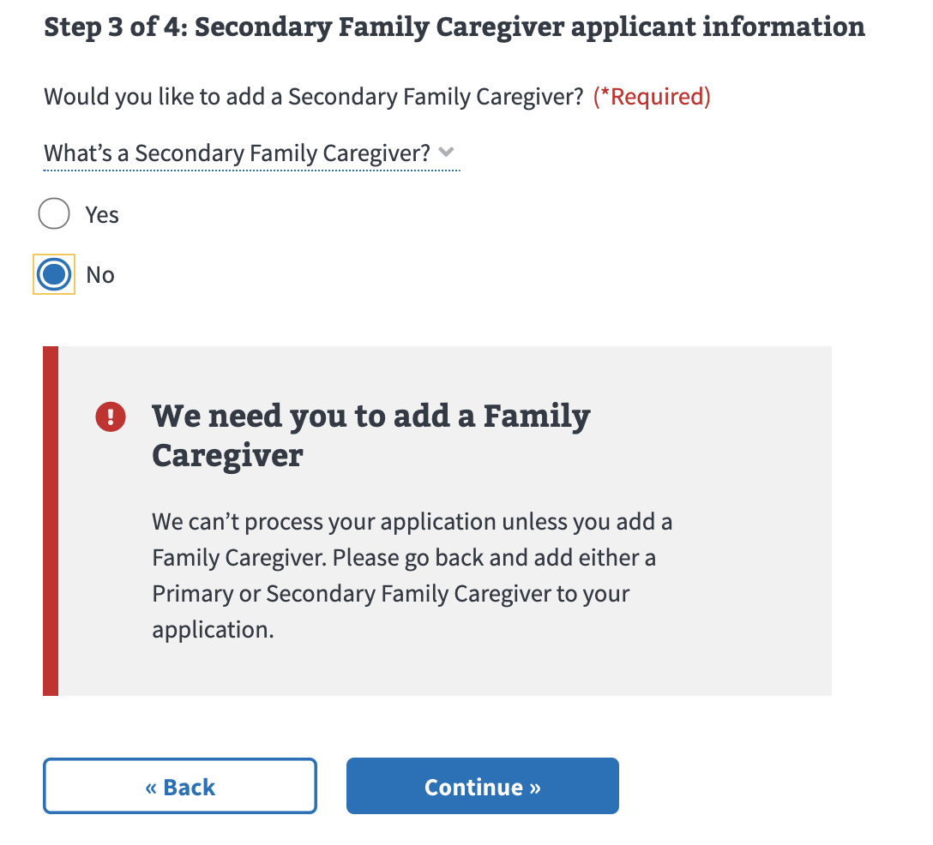  
*Figure 24. Family Caregiver listing error.*

### **Secondary Family Caregiver Information**

If the applicants add a Secondary Family Caregiver, additional fields will appear.

The person applying to be the Secondary Family Caregiver will be asked to enter general personal information (Figure 25).

*Figure 25. Secondary Family Caregiver general information.*

The application will tell the Secondary Family Caregiver what must be filled in. If they do not enter all the required information, they will not be allowed to move on to the next page.

The Secondary Family Caregiver’s Social Security number or tax identification number is requested, but not required to apply for the program. The caregiver applicant will receive an error message (Figure 26) if they put in a number that is not 9 digits, or if they repeat a number that has been entered elsewhere on the form.

*Figure 26. Error with Secondary Family Caregiver’s Social Security or tax ID number.*

Next, the Secondary Family Caregiver will be asked to fill in contact information (Figure 27).

*Figure 27. Secondary caregiver contact info.*

Primary phone number is required so a Caregiver Support Coordinator can contact the Secondary Family Caregiver to discuss the application (Figure 28). Email is not a required field.

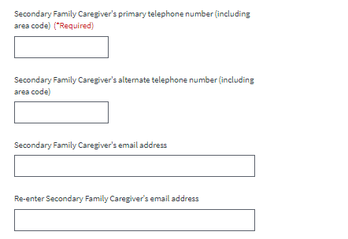  
*Figure 28. Secondary caregiver phone number.*

A drop-down menu prompts the Secondary Family Caregiver to indicate their relationship with Veteran (Figure 29). The form will not allow the applicant to continue without providing a response.

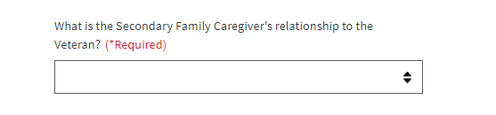  
*Figure 29. Secondary caregiver’s relationship with Veteran.*

Applicants are then asked if they would like to add another Secondary Family Caregiver (Figure 30). If the applicants do not add a second Secondary Family Caregiver, they will advance to the review screen.

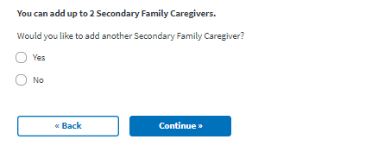  
*Figure 30. Option to add a second Secondary Family Caregiver.*

If they add a second Secondary Family Caregiver, they will advance to a new screen.

### **Secondary Family Caregiver (2) Information**

Next, the person applying to be the Secondary Family Caregiver (2) will be asked to enter general personal information (Figure 31).

*Figure 31. Additional Secondary Family Caregiver information.*

The application will tell the Secondary Family Caregiver (2) what must be filled in. If they do not enter all the required information, they will not be allowed to move on to the next page.  
  
The Secondary Family Caregiver’s Social Security number or tax identification number is requested, but not required to apply for the program. The caregiver applicant will receive an error message (Figure 32) if they put in a number that is not 9 digits, or if they repeat a number that has been entered elsewhere on the form.  
  
*Figure 32. Additional Secondary Family Caregiver, Social Security, or tax ID number error.*

Next, the Secondary Family Caregiver (2) will be asked to fill in contact information (Figure 33).

*Figure 33. Additional Secondary Family Caregiver contact information.*

A primary phone number is required so a Caregiver Support Coordinator can contact the Secondary Family Caregiver to discuss the application (Figure 34). Email is not a required field.

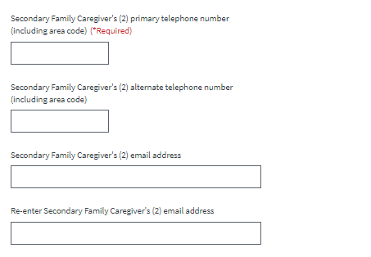  
*Figure 34. Secondary Family Caregiver primary phone number.*

A drop-down menu prompts the Secondary Family Caregiver to indicate their relationship with the Veteran (Figure 35). The form will not allow the applicant to continue without providing a response.

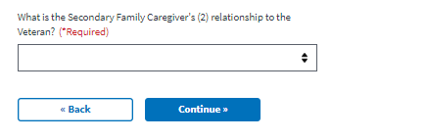  
*Figure 35. Relationship with Veteran.*

### **Representative documentation**

Next, the applicant is asked if they would like to share legal representative documentation (Figure 36). Sharing the documentation is completely optional, and there is no requirement to have a legal representative to be a part of PCAFC.

If the applicant selects “Yes. I want to upload my document now,” the next step will be to upload the documentation. If the user selects “Yes. But I’ll provide my document later.” or “No. I don’t have this document,” the Veteran will advance to the review screen.

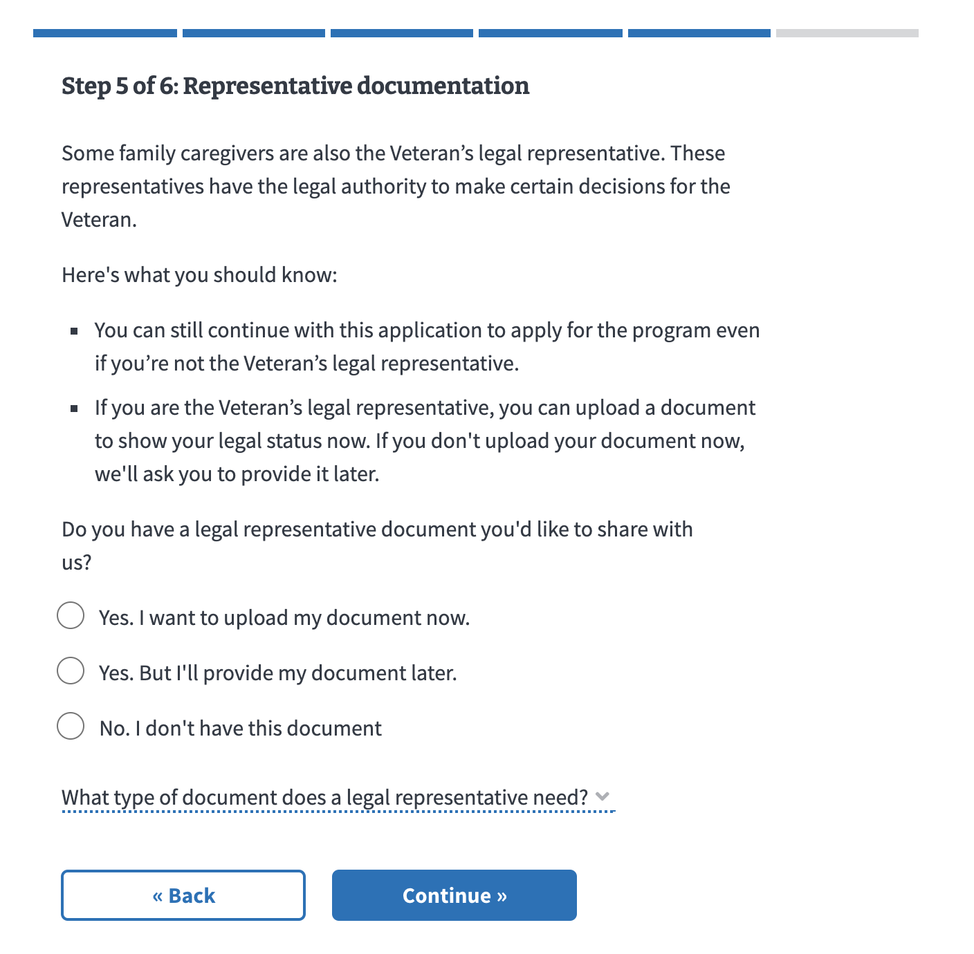  
*Figure 36. Question regarding legal representative documents.*

The type of document that a legal representative needs (Figure 37) can be accessed through a drop-down link.

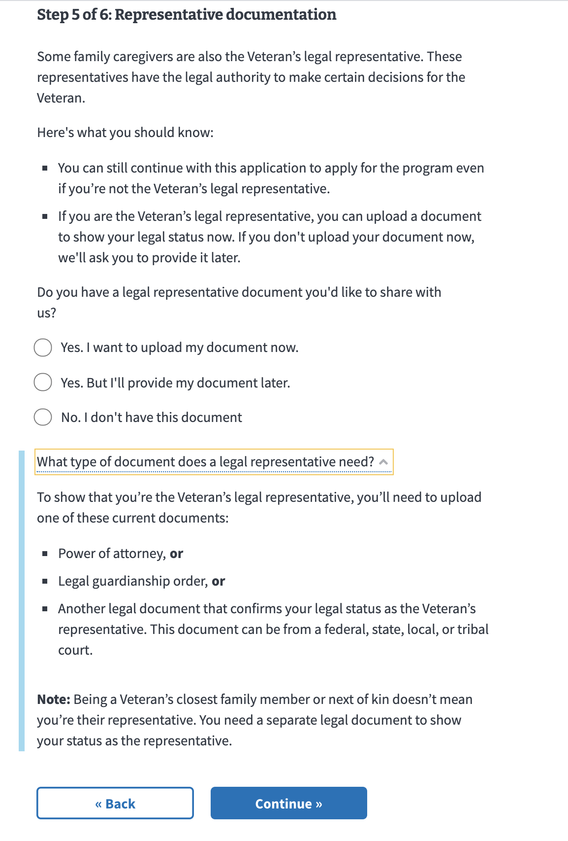  
*Figure 37. Types of legal representative documents accepted.*

**Upload your legal representative documentation**

If the applicant selects “Yes, I want to upload my document now.” they will be taken to the Upload your legal representative documentation screen (Figure 38). Using the “Upload” button, applicants can upload a PDF, JPEG, or PNG with a maximum file size of 25MB.

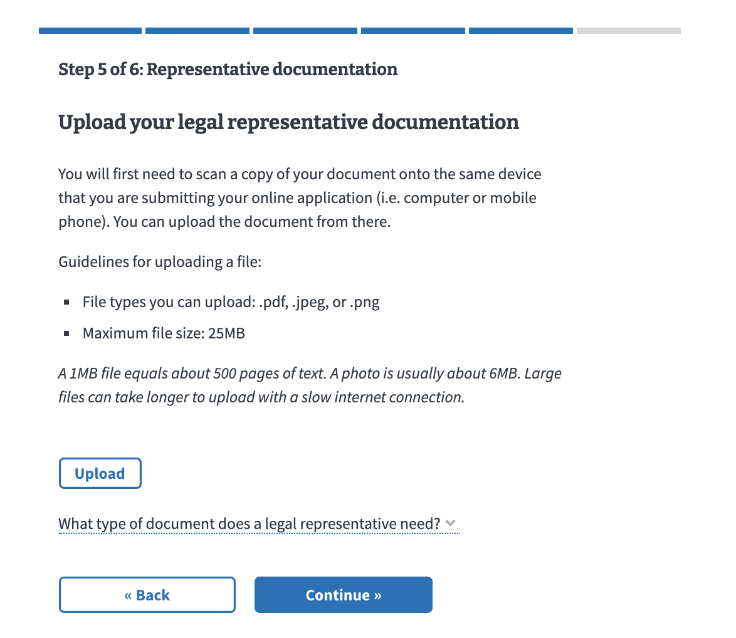  
*Figure 38. Uploading legal representative documentation.*

The type of document that a legal representative needs can be accessed through a drop-down link (Figure 39).

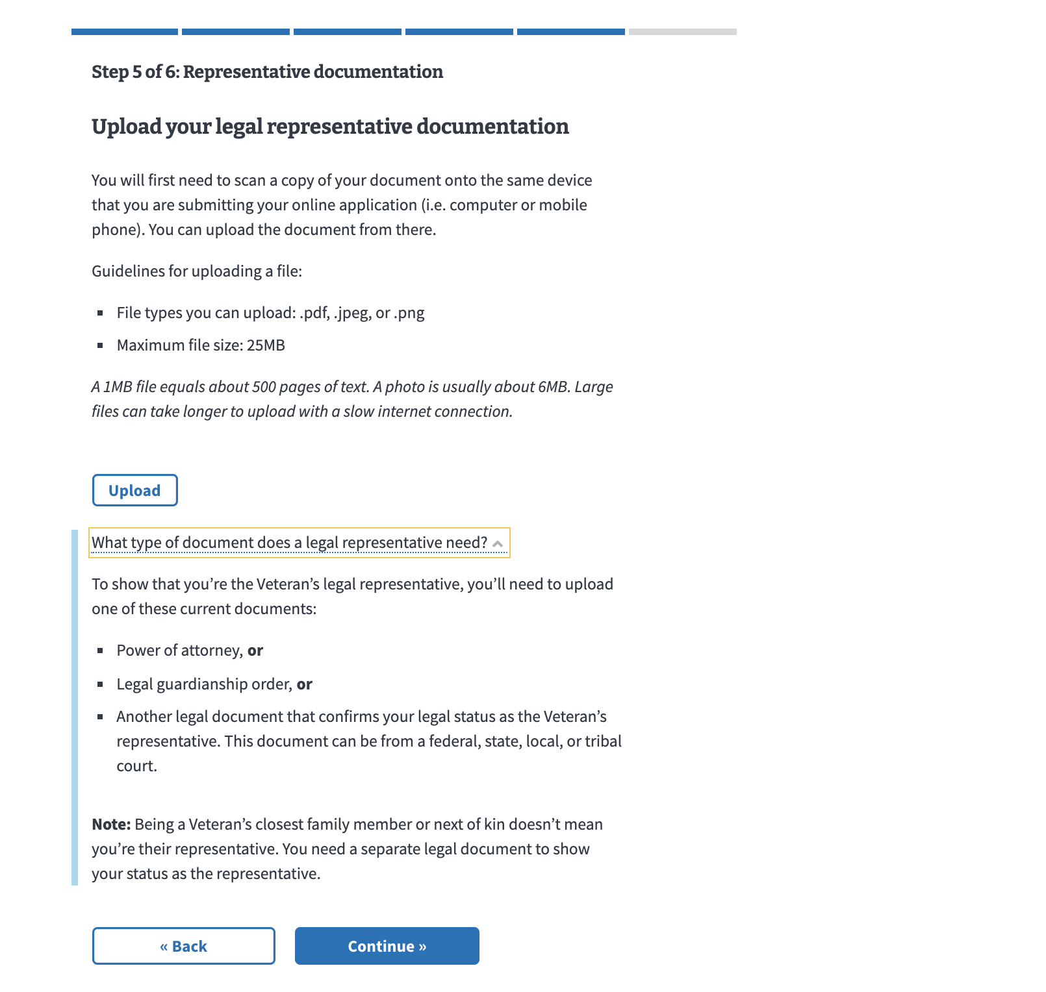  
*Figure 39. Types of acceptable legal documents.*

The applicant will see a confirmation if the file has been successfully uploaded with the file name (Figure 40). They can edit the file name and delete this file.

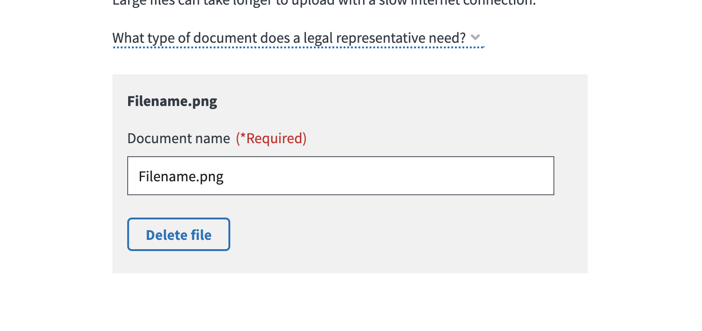  
*Figure 40. File upload confirmation.*

If there is a problem uploading a file, such as an Internet connection issue, a file being too big (over 25MB), or a wrong file type, they will receive an error (Figure 41) and can delete the file and try again.

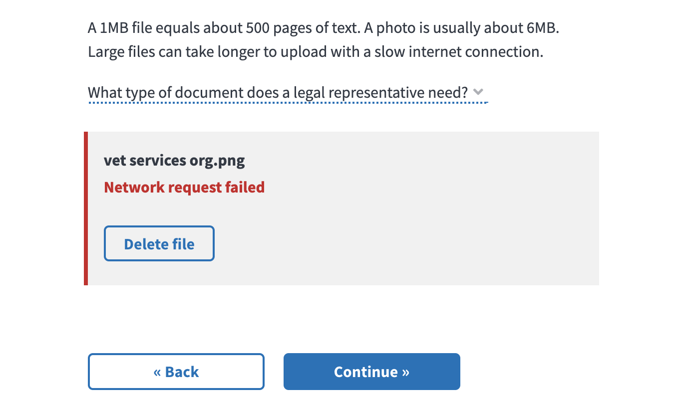  
*Figure 41. File upload error.*

# Review and Submission

### **Reviewing the Application**

The last step is the review application page (Figure 42). Here, the Veteran and each Family Caregiver can review the information that they’ve entered by clicking on each plus sign next to a section:  
  
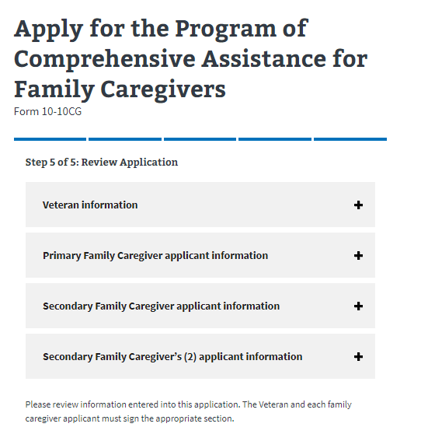  
*Figure 42. The review application page.*

If the Veteran and each caregiver applicant clicks on the plus sign, the section will open and show what the user entered (Figure 43). If something looks wrong, the applicant can select the “edit” button, and will be able to change the information. To save changes after editing, select the “update page” button.

*Figure 43. Expanding Veteran and caregiver information sections.*

### **Signature Section**

Once the Veteran and each caregiver applicant has reviewed the information and made any changes, they can proceed to the signature section. The Veteran’s statement of truth (Figure 44) will populate depending on what the applicant chose on the Representative documentation screen. If the applicant chose “No. I don’t have this document,” they will be shown this screen. The Veteran can type their full name as they input it into the form and select the “I certify the information is correct and true to the best of my knowledge and belief” checkbox.

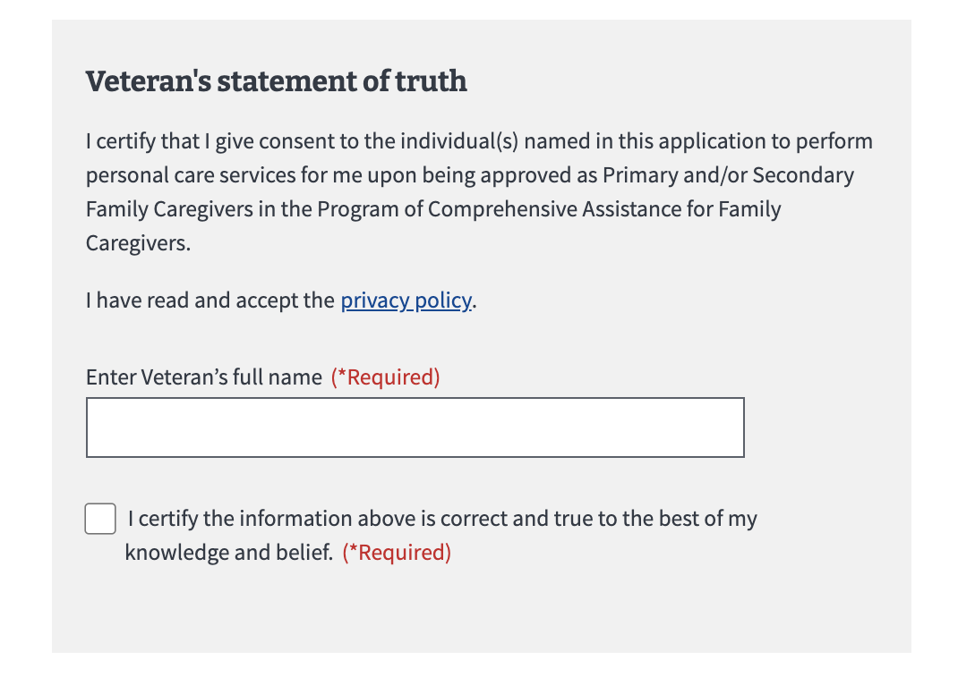  
*Figure 44. Veteran’s statement of truth.*

If the name does not match the name input into the form, they will receive this error (Figure 45). Within the error, they can see the name input in the form. They can edit the name and select the “I certify the information is correct and true to the best of my knowledge and belief” checkbox again.

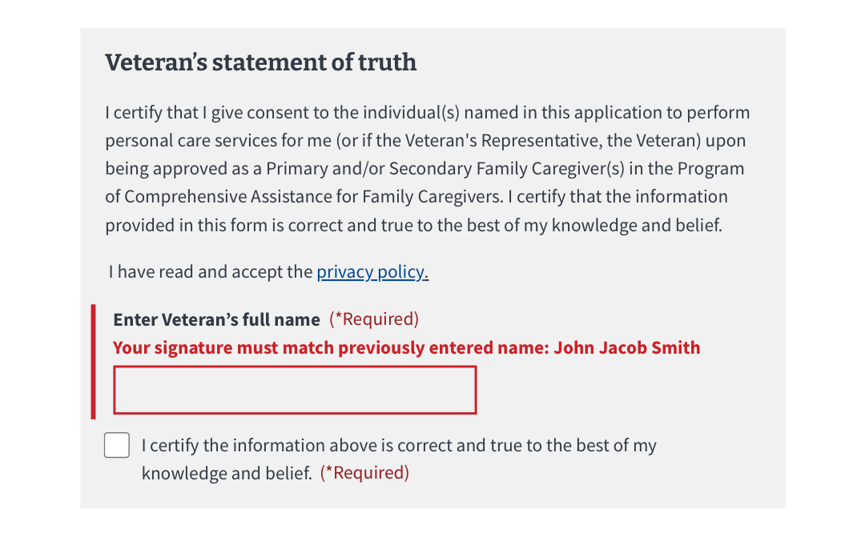  
*Figure 45. Signature error.*

If the applicant chose “Yes. I want to upload my document now” or “Yes. But I’ll provide my document later” on the Representative documentation screen, they will see this screen (Figure 46). The representative can input their full name and select the “I certify the information is correct and true to the best of my knowledge and belief” checkbox.

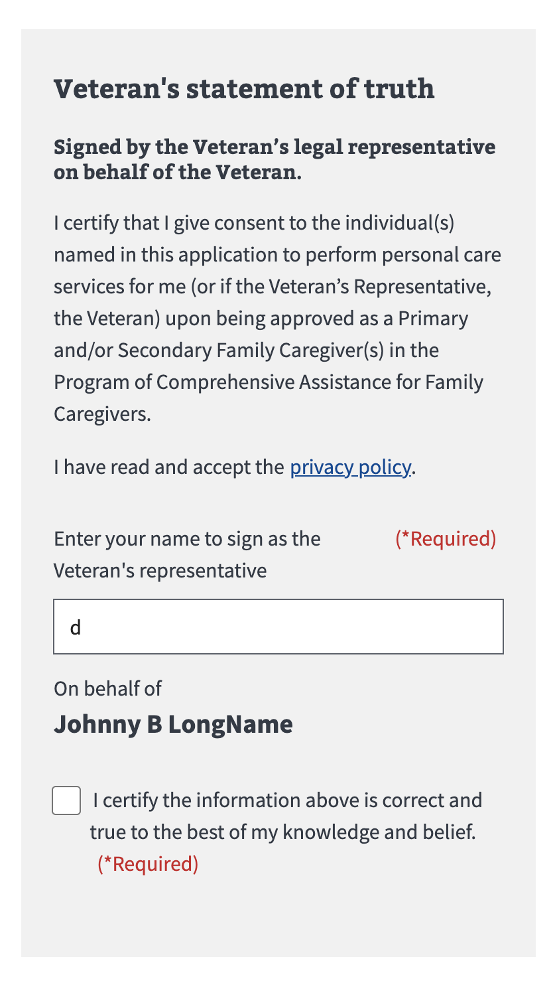  
*Figure 46. Signing for document.*

Next, each caregiver applicant can type their full name as they input it into the form and select the “I certify the information is correct and true to the best of my knowledge and belief” checkbox (Figure 47).

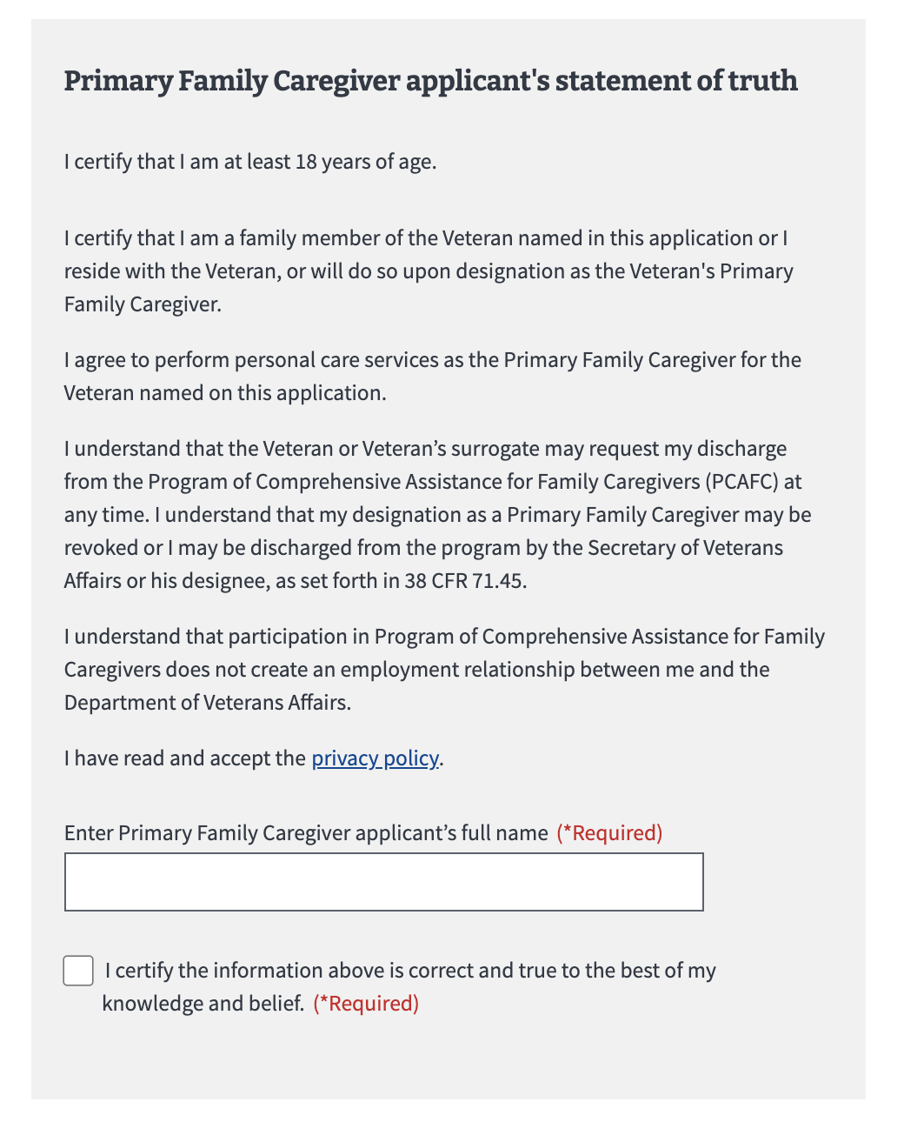  
*Figure 47. Primary caregiver’s statement of truth.*

If the name does not match the name input into the form, they will receive this error (Figure 48). Within the error, they can see the name that was input earlier in the form. They can edit the name and select the “I certify the information is correct and true to the best of my knowledge and belief” checkbox again.

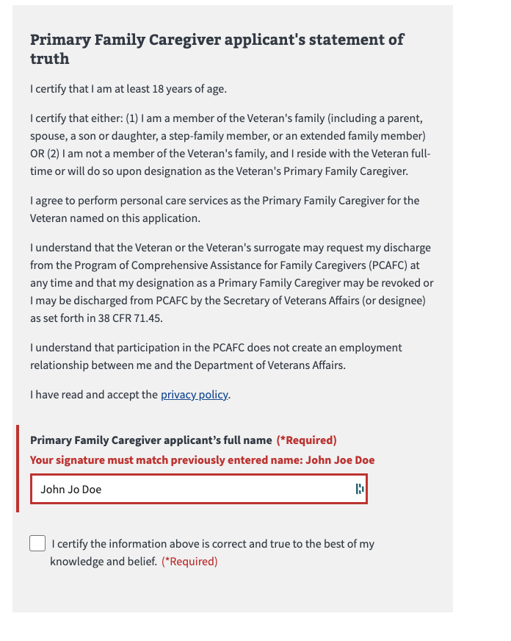  
*Figure 48. Primary Family Caregiver signature error.*

### **Submitting the Application**

Once the Veteran and each caregiver applicant has input their names, they can select to submit their application (Figure 49).

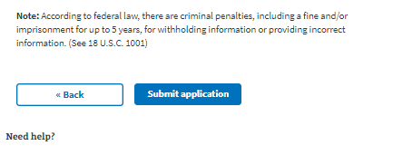  
*Figure 49. Submit the application.*

After selecting “submit application,” the applicants will be shown the below page (Figure 50) which contains a summary of the information, as well as additional information links that can help them understand the process for their application. They will also be able to print out the verification page and keep it for their records.

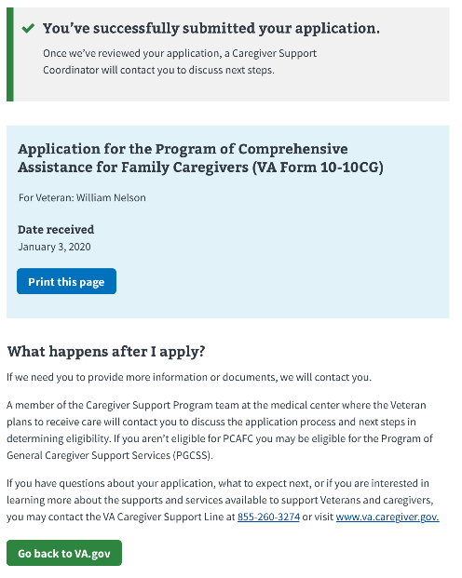  
*Figure 50. Information summary.*

### **Troubleshooting a Submission Error**

If the application fails to submit, the applicant will receive the following error message (Figure 51) on the Review and Submission page.

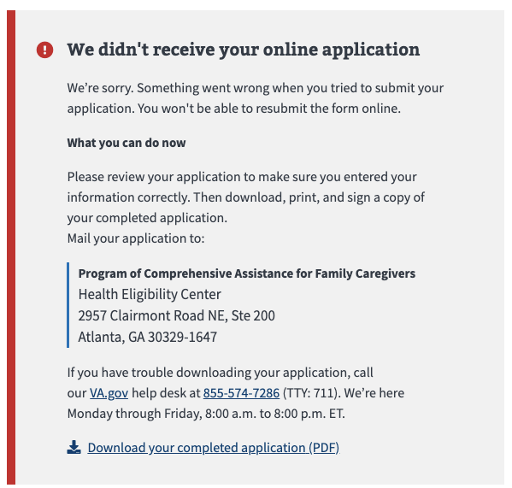  
*Figure 51. Application submission failure.*

If the applicant receives this error, they can carefully review the information submitted. If they see an error, they can fix it in the “review” field.

They will not be able to resubmit their online application unless they close their browser and start a new session. However, they can click the “download your completed application (PDF)” link at the bottom of the error message. The completed PDF will be saved to their computer.

Once they print out the completed PDF, the Veteran and each of the Family Caregiver applicants will need to checkmark the acknowledgment and sign. The application can be mailed to the address listed in the error message.

If the applicant tries to download the PDF but it fails to generate, applicants will receive one of two error messages:

**Error message 1:** (Code 400): Applicants will receive this message if there is an error generating the PDF (Figure 52).

  
*Figure 52. Form could not be downloaded.*

**Error message 2:** (Code 500): Applicants will receive this message if there is a failure on the VA.gov back end (Figure 53). Applicants receiving this message can try to submit the form later.

  
*Figure 53. VA.gov back-end failure.*

Table of Figures

*Figure 1. 10-10CG eligibility information.*  
*Figure 2. Beginning the application.  
Figure 3. Button to begin online application.  
Figure 4. Notice of upcoming scheduled maintenance.  
Figure 5. Tool unavailable due to maintenance.  
Figure 6. Pre-application information for Program of Comprehensive Assistance for Family Caregivers.  
Figure 7. Caregiver Support Coordinator information.  
Figure 8. General position information for 10-10CG application.  
Figure 9. Area where user enters Veteran’s Social Security or tax information.  
Figure 10. Veteran contact information.  
Figure 11. Area for primary phone number.  
Figure 12. Section for recent medical care.  
Figure 13. Where the Veteran plans to receive care.  
Figure 14. Applying for benefits for a primary family caregiver.  
Figure 15. Definition of primary caregiver.  
Figure 16. Primary Family Caregiver general information.  
Figure 17. Social Security or tax ID number error.  
Figure 18. Caregiver contact information.  
Figure 19. Required caregiver phone number.  
Figure 20. Caregiver relationship to Veteran.  
Figure 21. Caregiver’s health coverage.  
Figure 22. Secondary Family Caregiver.  
Figure 23. Secondar Family Caregiver definition.  
Figure 24. Family Caregiver listing error.  
Figure 25. Secondary Family Caregiver general information.  
Figure 26. Error with Secondary Family Caregiver’s Social Security or tax ID number.  
Figure 27. Secondary caregiver contact info.  
Figure 28. Secondary caregiver phone number.  
Figure 29. Secondary caregiver’s relationship with Veteran.  
Figure 30. Option to add a second Secondary Family Caregiver.  
Figure 31. Additional Secondary Family Caregiver information.  
Figure 32. Additional Secondary Family Caregiver, Social Security, or tax ID number error.  
Figure 33. Additional Secondary Family Caregiver contact information.  
Figure 34. Secondary Family Caregiver primary phone number.  
Figure 35. Relationship with Veteran.  
Figure 36. Question regarding legal representative documents.  
Figure 37. Types of legal representative documents accepted.  
Figure 38. Uploading legal representative documentation.  
Figure 39. Types of acceptable legal documents.  
Figure 40. File upload confirmation.  
Figure 41. File upload error.  
Figure 42. The review application page.  
Figure 43. Expanding Veteran and caregiver information sections.  
Figure 44. Veteran’s statement of truth.  
Figure 45. Signature error.  
Figure 46. Signing for document.  
Figure 47. Primary caregiver’s statement of truth.  
Figure 48. Primary Family Caregiver signature error.  
Figure 49. Submit the application.  
Figure 50. Information summary.  
Figure 51. Application submission failure.  
Figure 52. Form could not be downloaded.  
Figure 53. VA.gov back-end failure.*